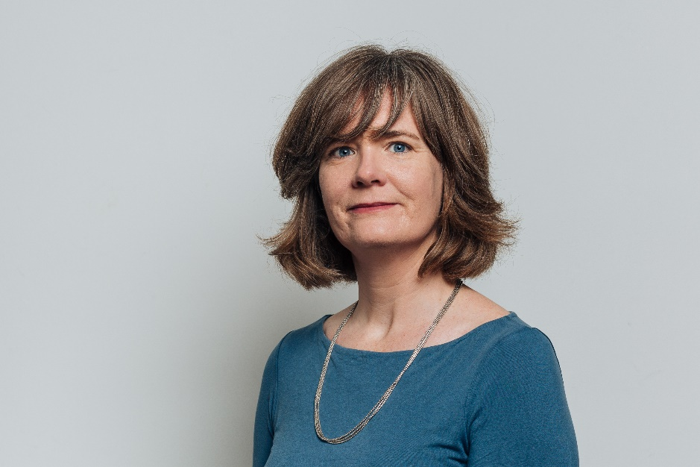

Sarah Bell is Professor of Environmental Engineering at University College. She is an Engineering and Physical Sciences Research Fellow working on bottom-up approaches to infrastructure resilience. She is the Director of the Engineering Exchange, which aims to connect local community groups with researchers in engineering and the built environment. Her most recent book ‘Urban Water Sustainability’ was published in 2018 by Routledge Earthscan.

